Meet and greet Coffee Fellowship

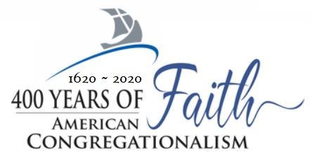

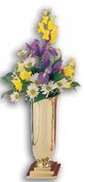





What is Christ the King Sunday?

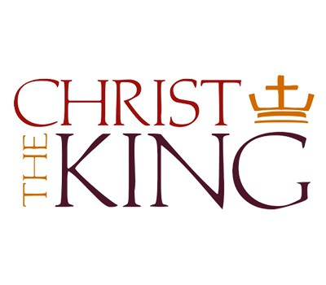

Christ the King Sunday celebrates the full authority of Christ as King and Lord of the universe. It is celebrated on the final Sunday of Ordinary Time, the Sunday before Advent. Its three-fold purpose in the liturgy is: 1.) That Christians would gain strength and courage as we are reminded that Christ must reign in our hearts, minds, wills, and bodies. 2.) That leaders and nations would see that they are bound to give respect to Christ. 3.) That civil governments would see that the Church has the right to freedom, and immunity from interference from the state.

In our 21st Century world, where secular humanism has been embraced to the extreme, for many, the only authority they recognize is themselves. The idea of Christ as ruler is rejected. But, in the midst of our culture’s chaotic displays of vanity and self-deception, we proudly celebrate Christ as the loving, merciful - and just - king of the universe who is to be praised, glorified and fully submitted unto.

Carla Sonson,

*In memory of Doris and Adrian Christian*



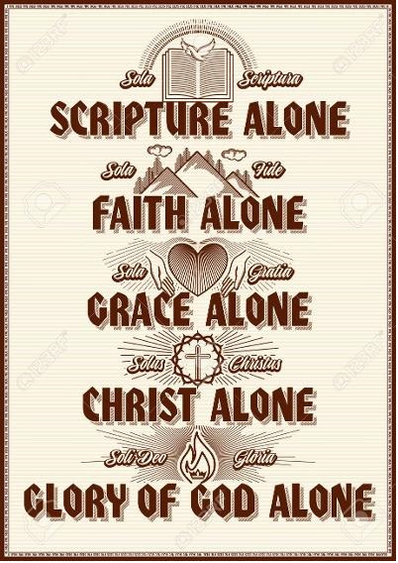

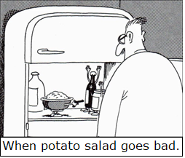

Article 12: Regeneration is a Supernatural Work

Scripture teaches that God’s work of regeneration - of being reborn and converted – is accomplished without our help. Rather, it is an entirely supernatural work. As a result, all those in whose hearts God works are unfailingly and effectively reborn and actually come to faith in Jesus Christ.

Article 14: The Way God Gives Faith

The way that God grants faith is described in Ephesians 2:8-10, which says: For by grace you have been saved through faith. And this is not your own doing; it is the gift of God, not a result of works, so that no one may boast. For we are his workmanship, created in Christ Jesus for good works, which God prepared beforehand, that we should walk in them.



Thanksgiving Dinner……………………….…Thursday 26th at 3:30 p.m.

Hanging of the Greens………….…………..Friday, Nov 27th at 5:00 p.m.

Next Diaconate Meeting…………………..Tuesday, Dec 1st, at 6:00 p.m.

Next Council Meeting………………….…Tuesday, Dec. 1st, at 6:30 p.m.

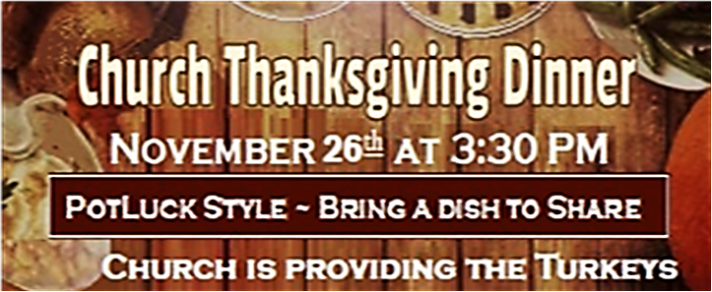

7900 Fort King Road – Zephyrhills, FL 33541

813-780-6027 / [fcczh@aol.com](mailto:fcczh@aol.com)

Radio Frequency 87.9

www.fcczhills.org

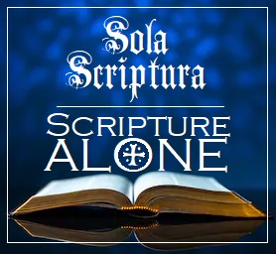

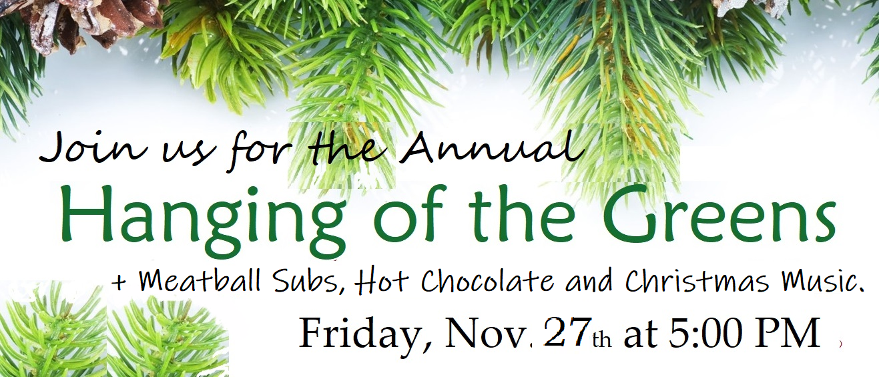

IMPORTANT Church Attendance Information and Liability Waiver.

By your attendance you are acknowledging that an inherent risk of exposure to bacteria, viruses, and other microscopic particles that cause illness in humans, including COVID-19 exists in any public place where people are present. You and any guests voluntarily waive all rights and assume all risks related to said exposure and agree not to hold First Congregational Church of Zephyrhills, its officers, employees, agents, contractors, or volunteers liable for any illness or injury that may result either now or in the future.

The Chancel Flowers are placed by:

Canons of Dort

~ The Third and Fourth

Main Points of Doctrine

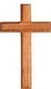

F**irst**

C**ongregational**

C**hurch***of* Z**ephyrhills**

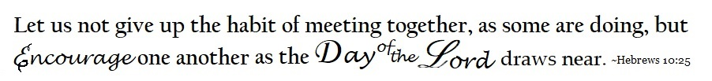

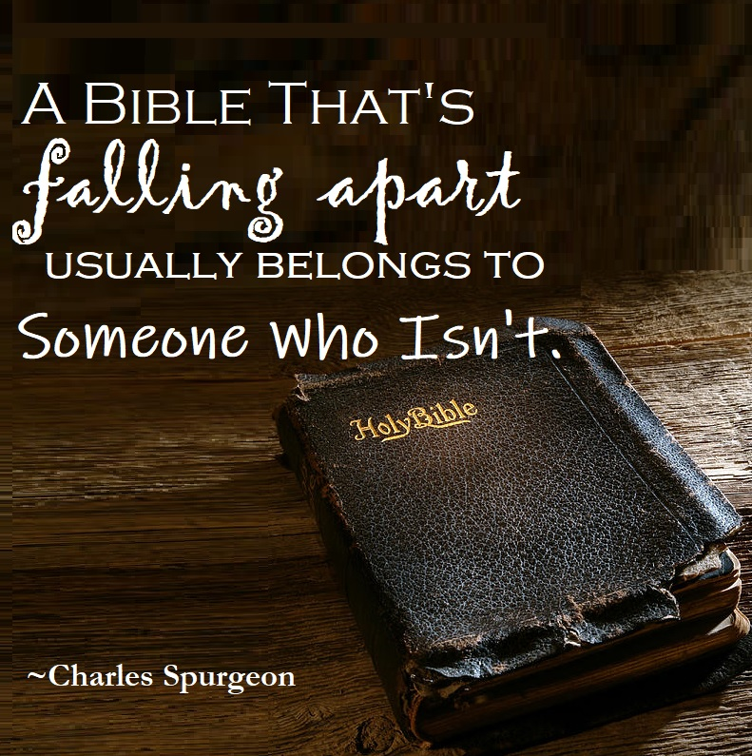

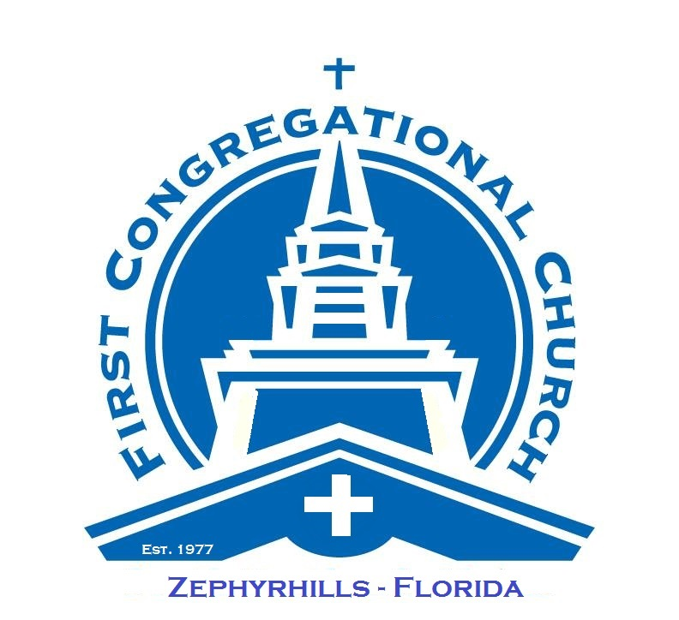

The Lord’s Day

*N o v e m b e r 2 2 , 2 0 2 0*

Let Us Glorify God

*1 0 : 0 0 a. m.*

Prelude *Piano/Chancel Organ*

Sounding of the Bell

Flag-Folding Ceremony

Call to Worship

† *Please stand as you are able.*

† Introit *“Majesty”* Page 10 ( Verse 1 )

Lighting of the Candles

† Hymn *“Glory to His Name”* Page 493 ( Verses 1,3,4 )

† Prayer of the Day and The Lord’s Prayer

† Anthem *“Gloria Patri”* Page 812

Hymn *“Crown Him with Many Crowns”* Page 45

( Verses 1.3.4 )

Let Us Pray For One Another

Pastoral prayer

Prayer Response *“O God, Give Us Your Blessing”* Psalter 67B

( Verses 1,3 )

Responsive Reading: Canons of Dort: # (See Reverse)

Let Us Return Thanks and Praise unto the LORD

Receiving the Tithes and Offerings

† Doxology and Offertory Prayer

Let Us Lift Our Voices in Praise

Hymn *“All Creatures of Our God and King”* Page 63

( Verses 1,2,5)

Special Music

Exposition of the Word and Confession of Faith

Sermon  “*The Eternal WORD”*

Psalm 119

† The Apostles Creed

† Closing Hymn *“Jesus Saves”* Page 438 ( Verses 1,2)

† Benediction

† Anthem *“The Family of God”* Page 419

Depart in Peace to Love and Serve the Lord

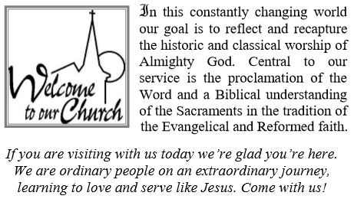

**Our Mission**

To Present Christ to Everyone,

Everywhere, at Every Available Opportunity.

**Our Vision**

To be a Loving, Caring Church

Whose Arms Embrace All that Come**.**

**The Lessons Appointed for Use on**

Christ The King Sunday

Ezekiel 34:11-16, 20-24 •Ephesians 1:15-23

Matthew 25:31-46

**We Affirm the Following:**

* The Holy Trinity of God - Father, Son, and Holy Spirit.
* God has revealed Himself fully and decisively in Holy Scripture. We believe the Bible, consisting of the Old and New Testaments, to be the inspired, infallible and authoritative Word of God and our guide for faith and life.
* There is only one way to Salvation - through Jesus Christ.
* The sanctity of human life based on our creation in the image of God and our election by God for service in His Kingdom. This leads us to respectfully affirm the sanctity of life at every stage, from conception to ordinary death.
* The Biblical guidelines for human sexuality: That marriage is the exclusive union of one man and one woman; and fidelity and holiness in marriage and chastity outside of marriage for the sake of the Kingdom.
* God made all people from one man and although people can be distinguished by different ethnicities and nationalities, we are all one human race and absolute equals before God in both creation, the need for repentance and the offer of redemption.
* That the mission of the Church is to spread the Good News of the Gospel in every word and deed. Proclaiming to the world the atoning death and resurrection of Jesus Christ and seeking to bring every person into a life of faith, discipleship and submission to Him.

**Deacon of the Month:** Ginny Jennings

Sanctuary Ushers: Anita & Marshall Whitcomb

Drive-In Usher: Clara Vosteen

Offering Last Sunday:…………………………….$2328.00

Campus Attendance Last Sunday:………….……112

……

Rev. H. Joseph Kler Pastor’s Cell 813-323-0802

Senior Pastor / I.F.O.C. Chaplain Vickie’s Cell 863-409-8850

Rev. John O. Strauss …… Minister of Music / Choir Director

Council President . . . . . . . . . . . . . . . . . . John Vosteen

Vice-President . . . . . . . . . . . . . . . . . . .  Marshall Whitcomb

Multi-Media . . . . . . . . . . . . . . . . . . . . Ric Romyn

Pianist . . . . . . . . . . . . . . . . . . . . . . . . Dee Schultz

Church Council

Don Binkley (Interim) • Kathy Honkala • Carolyn Hunt

Vickie Kler • Bill Thompson • Clara Vosteen • Shirley Witchley

Laura Davis-Rotolo

Office Manager / Church Secretary

Church Office Hours:

Tuesday – Friday: 9:00 AM to Noon.

Phone: 813-780-6027

Website: www.fcczhills.org Email: [fcczh@aol.com](mailto:fcczh@aol.com) 



resbyterian

**19911 Bruce B. Downs Boulevard**

**Tampa, Florida 33647**

**Phone: 813-973-2484**

**Fax: 813-973-4673**

**Email: office@tampabaypresbyterian.org**

**Web site: www.tampabaypresbyterian.org**

Tampa Bay

 Church

*Answers For Life!*

**New Tampa Christian Academy**

**Phone: 813-973-2443**

**Email: ntca@newtampachristianacademy.org**