

F**irst**

C**ongregational**

C**hurch***of* Z**ephyrhills**

**“Big Enough to Serve - Small Enough to Care!”**





IMPORTANT

Drive-In Church Attendance Recommendations

To stop the spread of coronavirus, health and government officials recommend maintaining a distance of 6 feet from other people. This reduces the chance of contact with those knowingly or unknowingly carrying the infection.

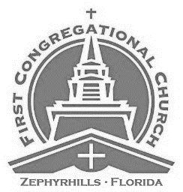

The Lord’s Day

March 29, 2020

Let Us Glorify God

Prelude

Sounding of the Bell

Welcome and Announcements

Call to Worship

Prayer of the Day and The Lord’s Prayer

1st Scripture Reading:

Hymn: *“Holy, Holy, Holy” Verses 1,2,3*

2nd Scripture Reading:

Let Us Pray For One Another

Pastoral prayer

Hymn *“Oh God Our Help in Ages Past” Verses 1,2,5*

Let Us Examine God’s Word Together

Sermon: *“Slow to Anger” Psalm 86 / Part 2*

The Apostles Creed:

I believe in God the Father Almighty, Maker of heaven and earth. And in Jesus Christ, His only Son, our Lord; Who was conceived by the Holy Spirit; Born of the Virgin Mary; Suffered under Pontius Pilate; Was crucified, dead and buried; He descended into Hell; The third day He rose again from the dead; He ascended into heaven; And sitteth on the right hand of God the Father Almighty; From thence He shall come to judge the living and the dead. I believe in the Holy Spirit; The Holy Christian Church, the Communion of Saints; The Forgiveness of sins; The Resurrection of the body; And the life everlasting. ~Amen~

Closing Hymn: *“To God Be the Glory”* Verses 1,2,3

Benediction

+++ Depart in Peace to Love and serve the Lord +++

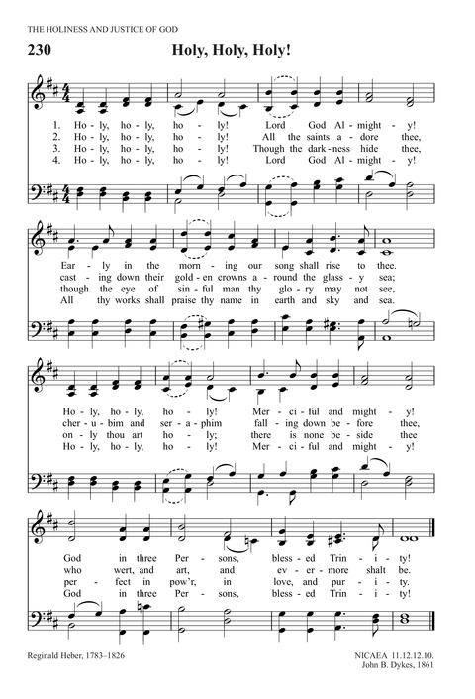

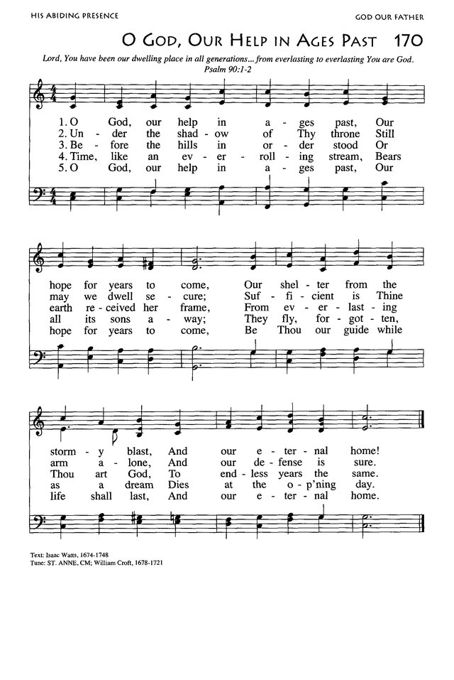

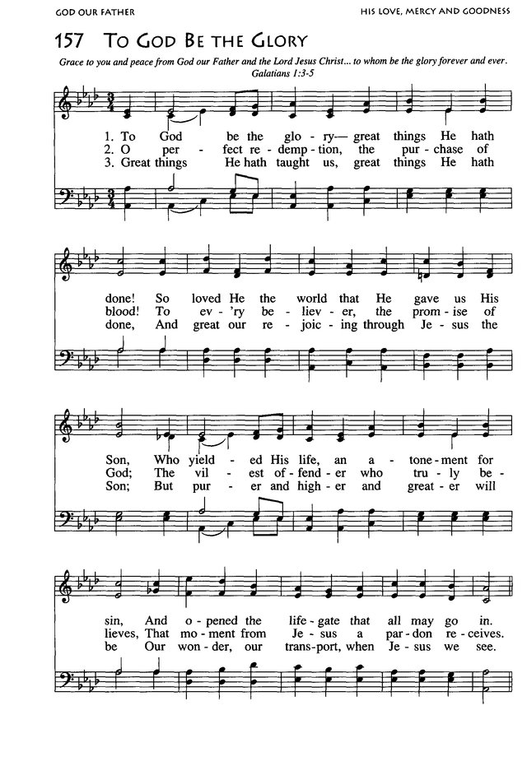

Loraine Menter in Memory of Loved Ones



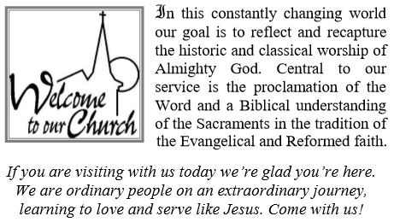

**We Affirm the Following:**

* The Holy Trinity of God - Father, Son, and Holy Spirit.
* God has revealed Himself fully and decisively in Holy Scripture. We believe the Bible, consisting of the Old and New Testaments, to be the inspired, infallible and authoritative Word of God and our guide for faith and life.
* There is only one way to Salvation - through Jesus Christ.
* The sanctity of human life based on our creation in the image of God and our election by God for service in His Kingdom. This leads us to respectfully affirm the sanctity of life at every stage, from conception to natural death.
* The Biblical guidelines for human sexuality: marriage as the exclusive union of one man and one woman, fidelity and holiness in marriage and chastity outside of marriage for the sake of the Kingdom.
* That the mission of the Church is to spread the Good News of the Gospel of Salvation in every word and deed. We are sent by Christ into all the world to proclaim the atoning death and resurrection of Jesus Christ and to bring every person into a life of submission to His Lordship.

**Our Mission**

To Present Christ to Everyone,

Everywhere, at Every Available Opportunity.

**Our Vision**

To be a Loving, Caring Church

Whose Arms Embrace All that Come**.**

The Lessons Appointed for Use on the



Fifth Sunday of Lent

Ezekiel 37:1-14 • Romans 8:6-11

John 11:1-45

Offering Last Sunday:…………………………….

Drive-In Attendance Last Sunday:………………….…….. **63**





To Limit The Spread Of Germs

And Prevent Infection Please

* Avoid Close Contact With People Who Are Sick.
* When you are sick, keep your distance from others
* Cover your mouth and nose when coughing or sneezing.
* Wash your hands often to help kill germs.
* Avoid touching your eyes, nose or mouth.
* Practice other good health habits. Get plenty of sleep, be physically active, manage your stress, drink plenty of fluids, and eat nutritious food.

